Introduction to device physics computational workshop
Dr Piers R F Barnes, Philip Calado
Department of Physics and Centre for Processable Electronics, Imperial College London
Last updated: September 2021
In this computational workshop we will explore how key properties of different combinations of semiconductor material layers influence the electrical behaviour of devices made from them. To simulate the behaviour of semiconductor devices we will use Driftfusion, an open-source software written in MATLAB developed by Dr Phil Calado, and described in detail in: https://arxiv.org/abs/2009.04384.
You will not need to have a detailed understanding of how the software works. However, having a sense of the general underlying series of steps needed to calculate and analyse a solution will help you to appreciate what you are doing during the workshop.
Driftfusion requires the user to define the properties of a structure of semiconductor layer(s) to simulate the ‘device’ (for example a p-type layer/intrinsic layer/n-type layer semiconductor stack). A user defined measurement protocol can then be applied to the device stack that you have created (for example a voltage sweep applied to the contacts). These inputs are used to calculate a ‘solution’ (the solution of the underlying equations and boundary conditions that define the charge transport, generation and recombination models of the stack of layers). The solution contains the electrostatic potential, the free electron concentration, and the free hole concentration profiles, showing how these quantities vary throughout the thickness the device, and how these profiles evolve with time in response to the measurement protocol. The solution can be analysed to calculate measureable quantities of the device, such as the current in response to a voltage sweep. These quantities can then be plotted for visualisation, for example a current-voltage curve could be plotted and used to find a device efficiency.
Figure 1 gives an overview of the steps taken using the software. Following successful completion of the steps given, Driftfusion outputs a MATLAB structure, sol (which we will refer to as a solution structure), containing the following elements:
– u, the solution matrix, a three-dimensional matrix with the dimensions[time,
space, variable]. The order of the variables are as follows:
1. Electrostatic potential
2. Electron density
3. Hole density
4. Cation density (where 1 mobile ionic carrier is stipulated)*
5. Anion density (where 2 mobile ionic carriers are stipulated)*
– x, the spatial mesh (this is a vector of the position points at which the solution is evaluated).
– t, the time mesh (this is a vector of the time points at which the solution is evaluated).
– par, the parameters object (this contains a record of the parameters used to calculate the solution).
* These variables will not be explicitly considered during this workshop.

sol can be used as the input argument for analysis functions contained within dfana or plotting functions within dfplot.

Fig. 1 The general workflow of Driftfusion. 1. The user defines a device in the properties definition step; 2. The device equilibrium state is solved for using the given recombination and transport models; 3. The user selects and runs an experimental protocol which defines time- dependent voltage and light conditions (derived from the appropriate generation model) to be applied to the equilibrium solution; 4. A solution is obtained that may be fed back into the protocol until a final solution is reached; 5. The solution is analysed to obtain calculated outputs; 6. The outputs are visualised using plotting tools.

Installing MATLAB
It will be easiest to undertake this workshop using a copy of MATLAB installed on you own computer. However, if necessary, you will be able to connect remotely to a workstation in the Physics Department which have MATLAB installed. You can find instructions on how to do this here:
https://www.imperial.ac.uk/admin-services/ict/self-service/connect-communicate/remote-access/remotely-access-my-college-computer/remote-desktop-access-for-students/
To install a copy of MATLAB on your machine, connect to the Imperial College VPN. Then go to the following link and follow the instructions on that web page:
https://www.imperial.ac.uk/admin-services/ict/self-service/computers-printing/devices-and-software/get-software/get-software-for-students/matlab/

Installing Driftfusion
Once you have installed MATLAB you need to download Driftfusion from Github. Navigate to the Driftfusion Github homepage:
https://github.com/barnesgroupICL/Driftfusion
It is important that you download the correct branch (version) of the code. To do this open the branch menu (highlighted with the red box in fig. 2) and select 2020-MRes-PEM-device-physics (fig 2., green box).
Fig 2. Selecting a code branch in Github.

Now open the Code menu (fig 3., green button) and select Download ZIP (fig 3., orange box).
Fig 3. Downloading a standalone ZIP from Github.
Unzip the file in the location of your choice. The folder contains a standalone version of the code.

Getting started
- Start MATLAB
- Navigate to the Driftfusion-MRes-PEM-device-physics-workshop-2020 folder on your hard drive in the file explorer on the left hand side of the MATLAB window (fig 4, green box).
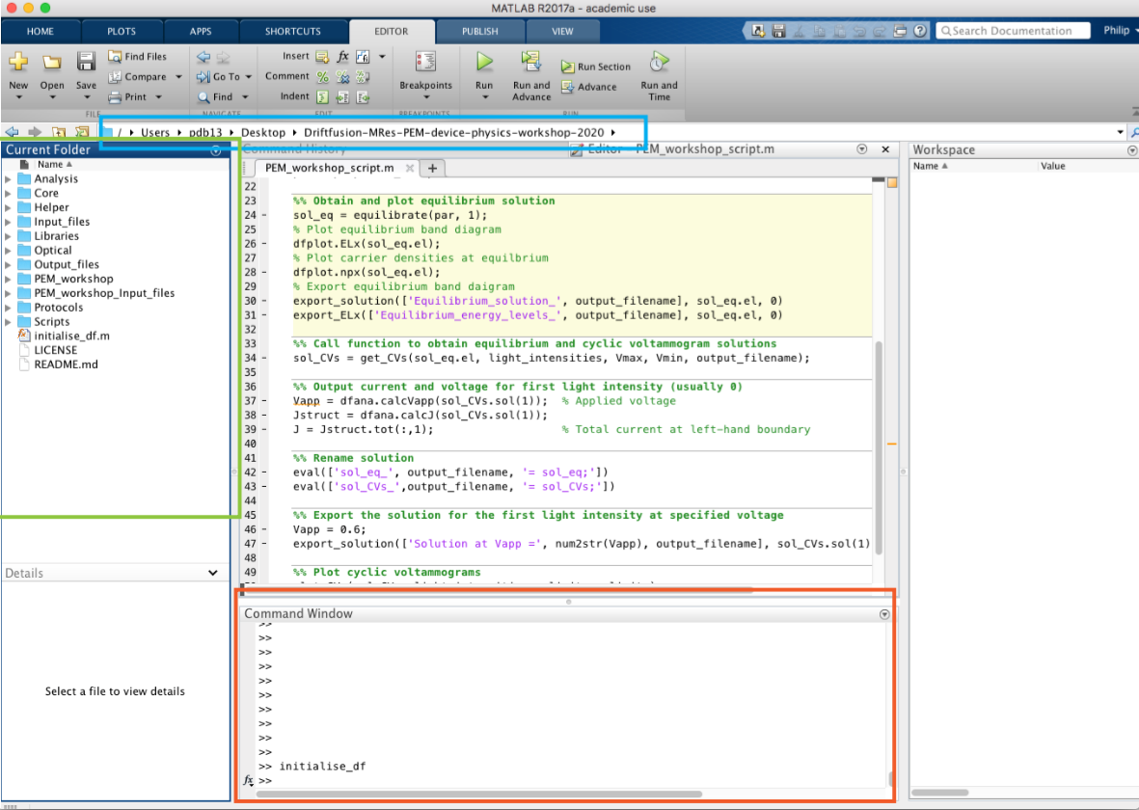
Fig 4. The MATLAB environment
3. Select the command window (fig 4, orange box) at the bottom and type initialise_df then press enter.
You are now ready to begin the workshop script.
Throughout today’s session it is important that you remain in the Driftfusion-MRes-PEM-device-physics-workshop-2020 folder and do not navigate further down the folder tree in the file explorer. The current active folder is given in the file path highlighted by the blue box in fig 4. If you encounter a problem the first thing you should check is that you are working in the Driftfusion folder and not one of its subfolders.
Keeping notes
As you work through the tasks in this workshop, we recommend that you keep notes of your observations using an electronic lab book (this could be a OneNote page for example) into which you paste your observations, and comments. If you are reasonably familiar with MATLAB you can analyse the results of the simulations using MATLAB, but it is also fine to read values off plots, or import data into excel or some other package for analysis if you’d prefer.

If you get stuck on some parts of the exercises, it is fine to move on to the next part. Be sure to discuss problems with a demonstrator when you get the chance. You can write “Question” in the chat and/or raise your hand in Teams, or alternatively contact a demonstrator directly.

1. Ohmic contacts and conductivity
In these first steps, we will simulate the simplest form of semiconductor device – a semiconductor layer sandwiched between two ohmic metal contacts. By performing a current-voltage sweep on this device we should be able to measure the resistance of the semiconductor layer, and, consequently find the conductivity of the semiconducting material.

Intrinsic semiconductors
The conductivity, $σ$, of a semiconductor is given by the sum of the products of the electron and hole mobilities, $μ_{e}$ and $μ_{h}$ , with their respective free carrier concentrations, n and p:
$σ=q\left(μ_{e}n+μ_{h}p\right)$
where q is the charge on an electron. In an intrinsic semiconductor at equilibrium, the concentration of electrons equals the concentration of holes and is given by the intrinsic carrier concentration, n_{i}:
$n_{i}=\sqrt{N_{C}N_{V}}\exp\left(-\frac{E_{g}}{k_{B}T}\right)=n(intrinsic, dark)=p(intrinsic,dark)$
An ideal Ohmic contact to semiconductor does not introduce any resistance in addition to the resistance of the semiconductor. Consequently, current vs voltage measurement of a semiconductor between Ohmic contacts should give a linear relationship (under dark conditions). The semiconductor conductivity is related to the resistance, R, of a material according to:
$R=\frac{d}{Aσ}$
where d is the thickness of the semiconductor and A is the area of the planar contacts.

Exercise 1.a Simulate a current voltage-curve of an intrinsic semiconductor with ohmic contacts, and measure the conductivity of the semiconductor
Show the contents of the “PEM_workshop” folder while remaining in the “Driftfusion-MRes-PEM-device-physics-workshop-2020” folder (use a single click on the triangle on the left of the folder symbol), then open the script “PEM_workshop_script.m” in the MATLAB editor.
You now need to edit the script so that it will load in the appropriate set of parameters for the device in this exercise. This can be done by setting the variable params_filepath in the script to:
params_filepath ='./CPE_workshop_Input_files/intrinsic_ohmic.csv';
% Filepath to the parameters file

This tells the software where to find the parameters for the device we wish to simulate. The key device parameters are stored in a comma separated variable (.csv) file within the “CPE_workshop_Input_files” folder.
(In MATLAB the “%” symbol indicates that any text to its right is a comment, if you wish to remove a line of code from the script it can be better to add a “%” in front of the line than deleting the line entirely.)
You can view and edit the values of the device parameters in the input file by opening it in a spreadsheet – the meaning of the different values are given in Appendix 1.
Make sure the “light intensity” variable in the script is zero. This defines the number of sun equivalents shining on the sample, and here we want dark conditions:
light_intensities = 0;

Run the script by clicking on the green “run” arrow: .

This will calculate a solution for a current density vs voltage sweep, and then plot figures showing the free electron and hole concentrations, the equilibrium energy level diagram, as well as another figure showing the current density vs applied voltage. Note that the metal contacts are simulated using the boundary conditions of the equations and hence only the semiconductor region is visualised in the plots. In this case the metals are assumed to have fixed workfunctions at the same level of the Fermi levels of the semiconductor. In later exercises we shall investigate the effects of offsetting the metal workfunctions from that of the semiconductor.
Use the current density vs voltage plot to find the areal specific reisitance of the semiconductor (the resistance multiplied by area (R A), with units $Ωcm^{2}$) using Ohms law (V = IR so that V/J = R A where J is the current density and A the contact area).
Use the values of the variables in the parameters file to find the semiconductor thickness, and thus find the “measured” conductivity of the semiconductor.
Now calculate the conductivity you expect given the input parameters to the simulation. Again, you will need to look in the input parameters .csv file and use the table in Appendix 1 to find the meaning of the symbols. How does this compare to the measured conductivity?
Optional exercise 1b. Behaviour under light
Try using a non-zero light intensity (for example 1 sun equivalent).
light_intensities = 1;

What happens to the current density vs voltage plot?
Can you think why the current-voltage curve looks different (not trivial)? (don’t spend much time on this – discuss with demonstrators)

Doped semiconductor with Ohmic contacts
In this exercise we will see how the conductivity changes when the semiconductor is doped. In Driftfusion you do not directly specify the doping concentration. Instead, you specify the equilibrium Fermi level of each semiconductor layer, E_{f0} and the corresponding doping concentration, N_{A} (acceptor density) or N_{D} (donor density) is calculated by the software. We would investigate at an n-type semiconductor layer here. Donor doping concentration is related to the Fermi level according to the following relationship:
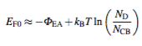
Exercise 2. Effect of doping on semiconductor conductivity
Calculate the equilibrium Fermi level required as an input parameter if you use an electron donor doping density of N_{D} = 2.09 x 10¹⁷ cm⁻³
You will need to find the values of N_{CB}, T, and the electron affinity, $Φ_{EA}$, from the intrinsic_ohmic.csv parameters file in order to calculate E_{F0}.
Once you have found E_{F0}, save a copy of the parameters file as /CPE_workshop_Input_files/doped_ohmic.csv
Now update the values of the parameter E_{F0} in your new ‘doped_ohmic.csv’ file. Also set the work function of the metal contacts, $Φ_{left}$, and $Φ_{right}$ the same value as E_{F0}. (Note that Driftfusion uses the convention that work functions have negative values.)
Update your script to read your new parameter file:
params_filepath ='./CPE_workshop_Input_files/doped_ohmic.csv';
% Filepath to the parameters file

Reset the light intensity to zero, then run the script.
Calculate the measured conductivity of the doped semiconductor from current-density vs voltage curve.
How does the measured conductivity compare to the conductivity expected from the input parameters?
How does the conductivity compare to that of the intrinsic device with Ohmic contacts, studied in Exercise 1?
What happens to the conductivity if you change the electron or hole mobility in the parameters file?

Asymmetric contacts with an intrinsic semiconductor
We will now explore the influence of changing the work function of the metallic contacts on the current-voltage behaviour of our device. We will start with the intrinsic semiconductor case (in the dark). In the previous examples, we simulated Ohmic contacts by setting the work functions of the simulation boundaries ($Φ_{left}$, and $Φ_{right}$) to be the same as the equilibrium Fermi level E_{F0}. This condition need not be the case, and $Φ_{left}$, and $Φ_{right}$can differ from the equilibrium Fermi level. Generally, this results in non-Ohmic behaviour.
Duplicate intrinsic_ohmic.csv and give the duplicated file a new name e.g intrinsic_asymmetric.csv
In your new parameters .csv file, adjust the value of $Φ_{left}$ to be 0.4 eV greater than E_{F0} and $Φ_{right}$to be 0.4 eV less than E_{F0}. The difference between $Φ_{left}$, and $Φ_{right}$ is known as the built-in potential ($Φ_{bi}$).
Edit the script to call the new parameter file e.g.:
params_filepath ='./CPE_workshop_Input_files/intrinsic_asymmetric.csv';
% Filepath to the parameters file

Make sure the light intensity is set to zero.
Run the script.
Exercise 3a. Current-voltage characteristics with asymmetric contacts
How has the current density vs voltage curve changed in comparison to the case with Ohmic contacts?
What does the energy level diagram look like?
What happens if you reverse the direction of these work function offsets?
What happens if you change the magnitude of the work function offsets?
What happens if you shift both work functions in the same direction?
Exercise 3b. Asymmetric contacts with light
Try running the some of the above cases with:
light_intensities = 1;
CONGRATULATIONS – you should have just created a virtual solar cell!
In this version of Driftfusion, we assume that free charge carriers are generated at a uniform rate throughout the semiconductor layer.
When you run the script, two variables called Vapp (the applied voltage) and J (the current density), are created in the workspace. You can print them out in the command window by typing the variable corresponding name and pressing ENTER. Either use MATLAB (if you are familiar with it), or copy and paste the values into a spreadsheet, to:
Determine the open circuit voltage (VOC), and short circuit current density (JSC) of your device.
Calculate the power density as a function of applied voltage by using the following expression:
P = -JV
Find the maximum power output from the device, and the corresponding current density (J_max) and voltage (V_max) values at the maximum power.
Calculate the efficiency of the device assuming, in this case, that the 1 sun equivalent irradiance corresponds to 100 mW cm-2.

Schottky barrier
A Schottky barrier can be formed when a metal and semiconductor (typically doped) with differing workfunctions are contacted. This creates an electrostatic potential barrier that impedes the flow of current in one direction. The distance over which the potential barrier falls is known as the space-charge layer (or depletion) width, w_{d} and is an important characteristic property of metal-semiconductor junctions:
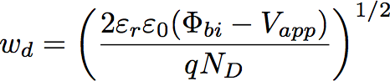
, where $ε_{r}$ is the relative dielectric constant of the semiconductor and $ε_{0}$ is the vacuum permittivity. In this situation, $Φ_{bi}$ is the difference in energy between the metal workfunction and the semiconductor equilibrium Fermi energy (the built-in potential) and V_{app} is the applied voltage.

Exercise 4a. Space charge layer width in a Schottky barrier
Estimate width of the space charge layer with for a Schottky barrier with a built-in potential of 0.7 eV and a doping density of N_{D} = 2.09 x 10¹⁷ cm⁻³, with Vapp = 0 V. Note: Distances have units of cm in the simulation and 1 cm⁻³ = 10⁶ m⁻³ .
Duplicate the .csv file that you created for the doped semiconductor with Ohmic contacts (doped_ohmic.csv) and give it a new name (e.g. Schottky.csv).
Create a built-in potential barrier of 0.7 eV by adjusting the left-hand electrode workfunction, Phi_left, to the appropriate value (it should be more negative than E_{F0}).
Verify your estimate for the space charge layer width using the energy level diagram by running the script with your new parameter set.
Verify that the following parameters influence the space charge layer width (w_{d}) according to the equation above:
- The built-in potential of the junction
- The doping density
- The semiconductor relative dielectric constant
What do current voltage curves look like in this case?

Optional Exercise 4.b Schottky junction capacitance
Estimate the capacitance (C) of the Schottky junction given that:
$\frac{C}{A}=\frac{ε_{r}ε_{0}}{w_{d}}$
Try plotting 1/C² against V_{app}. What relationship do you observe, what can you learn from it? (Consider the combining the capacitance equation above with the expression of w_{d}).

Metal-Insulator-Semiconductor
We will now consider a Metal-Insulator-Semiconductor device, this actually has an architecture corresponding to Metal-Insulator-Semiconductor-Metal since both sides have electrical connections, but the Semiconductor-Metal interface is normally Ohmic.
Our previous simulations have only involved one semiconductor layer between metal contacts. Driftfusion allows you to have any number of semiconductor or insulator layers. In this section we will examine a two-layer device (with metal contacts on each side). The two layers are connected by a narrow, graded, interface region where the properties of the first layer continuously transition to the properties of the next.
Exercise 5. Energy level diagrams of a M-I-S capacitor
We have prepared a two-layer input parameter template which can be called in the script using:
params_filepath ='./CPE_workshop_Input_files/2_layer_device.csv';
% Filepath to the parameters file

In a spreadsheet, adjust the values $Φ_{IP}$ and $Φ_{EA}$ and E_{F0} for the two layers, as well as $Φ_{left}$ and $Φ_{right}$ to create a Metal-Insulator-Semiconductor device. You will need to create a reasonably wide band gap semiconductor on one side (the insulator) and a narrower band gap on the other. You may also like to adjust the charge carrier mobilities in the materials. You will also need to decide on the thickness and dielectric constant of each layer.
Run the script to sweep the voltage between the contacts. The resulting current density should be very small at most voltages. You may like to increase the voltage scan range to more than the default values below, due to the large voltage drop across the insulating layer:
Vmax = 0.8; % Maximum voltage for cyclic voltammogram
Vmin = -0.8; % Minimum voltage for cyclic voltammogram
(don’t be surprised if the software crashes if these values are too large!)
You can plot the energy level diagram for the device at different applied voltages by changing the value of Vplot in the script from zero (this is the equilibrium case if the light intensity is also zero) to the applied voltage of interest (see below for an example where the energy level diagram corresponding to an applied voltage of 0.6 V will be plotted).
%% Plot energy level diagram at applied bias Vapp for first light intensity
Vplot = 0.6;
Can you simulate, and create plots of the device in the accumulation and depletion regimes?
Based on your simulations can you roughly estimate the capacitance of the device for different values of V_{app}? What would you need to do to calculate the capacitance more accurately?
Explore the consequence of insulator dielectric constant and thickness by varying the appropriate parameters in the 2_layer_device.csv file.

p-n junction
Exercise 6. The performance of p-n junctions as photodiodes
Adjust the two-layer parameter input file to compare the current-voltage and energy level diagram behaviour of a p-n homojunction, then try exploring type I, type II and type III p-n heterojunctions. For simplicity ensure that the metal electrode workfunctions are at the same level as the equilibrium semiconductor Fermi levels.
For each different junction types see how well they work as a solar cell or photodiode.

Design a solar cell
Exercise 7. Explore
Create a solar cell of your choice – discuss with demonstrators how to do this! You may wish to use a three semiconductor layer structure:
params_filepath ='./CPE_workshop_Input_files/3_layer_device.csv';
% Filepath to the parameters file

Examine the effect of setting low conductivity in the contact layers influences the current density-voltage curve and corresponding energy level diagrams.

Appendix I: Symbols definitions and Driftfusion variable names
